P.O. Box 218
Locust Grove, OK 74352
Phone: 918-479-6356 // Fax: 918-479-6316
fumclg@sstelco.com
Greetings from your pastor:
Hardly seems possible the new year is beginning. Seems to be going by so very fast and yet sometimes it drags on and on and if it weren’t for the fact that we get older we might not know anything is different. Changes are one of those things we don’t much like to do, yet we do it all the time. Think about the first time you attended church here. How have things changed since then. Unless you are fairly new, I know you’ve been through a pastor or ten. There are times this church had more children, but they grew up. Many of the children we have now will be invited to attend Confirmation Classes in the Fall this year. Do you remember your Confirmation?
2023
On the 8th of January we will be renewing our covenant with God and remembering our baptism. Do you remember your or were you like me, an infant. God remembers your baptism. As you reach into the water and pull out a trinket you may have feelings that wash over you that you do not expect. That will be the Holy Spirit.
Like everywhere, the church is struggling. These are difficult times. I’m wondering throughout history how many people sat in pews and worried about the future of their church. How many times in YOUR life have you? The Finance Committee will begin sharing Offerings and Expenses, so you have a better idea of where we are financially. Many churches have done this for years. Money is a tool not to be loved or feared.
I don’t make New Years resolutions…I’m changing and adapting every single day to be the best me I can be. My prayers always ask God to make me better, to give me the strength and courage to change what is necessary.
What will you change this year OR What changes will you accept? Ponder those questions carefully.

John 3:17-18 (MSG)
¹⁶⁻¹⁸ “This is how much God loved the world: He gave his Son, his one and only Son. And this is why: so that no one need be destroyed; by believing in him, anyone can have a whole and lasting life. God didn’t go to all the trouble of sending his Son merely to point an accusing finger, telling the world how bad it was. He came to help, to put the world right again. Anyone who trusts in him is acquitted; anyone who refuses to trust him has long since been under the death sentence without knowing it. And why? Because of that person’s failure to believe in the one-of-a-kind Son of God when introduced to him.
In Christ’s service I remain,
Pastor Sharon Kay Cochran
January Birthdays
January 1 – Paula Duncan
January 7 – Beth Cooper
January 13 – Michelle Ross
January 15 – Rod Pfeifffer
January 22 – Isiah Woolman
January 23 – Jim Sisk
January 23 – Johnny Holman
January 23 – David Frazier
January 28 – Justen Kirby
January 31 – Tanya Holman
January 31 – Kaitlyn Stephens

January Anniversaries
None

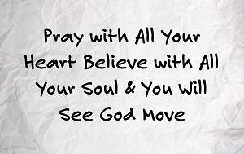
December
Prayer List

In September we prayed for the following people:

-Alan Shrum
-Kathy Bussard
-Michelle Ross & Family
-Michelle’s Co-worker
-Pastor Sharon
-Brooke’s friend, Demi & her Mom
-Everly (Carol Holman)
-John & Linda Oliver
-Jo Coverdell
-Sydnie (Nursery Attendant)
-Carol Holman
-Carol Holman’s cousin, Marilyn
-Sonya Bell
-Marcia Velia’s great-grandson, Zarren
-Linda Nichols
-Our homebound: June Pierce, Ron Velia, Madelyn O’Neal, Virginia Chaffin, Marvelyn Braaten, Barb Breedlove
-Town Leaders, State Leaders, National Leaders, World Leaders
Congratulations
to Chase Anderson (father), Stephanie Anderson (grandmother), and Brooke Anderson (Aunt) on their new family addition! Brian (Trae) Anderson was born on Wednesday, December 7th, at 5:58 am. He came in at 8 lbs, 11oz and 22 inches long.
Church Financial Report
For November 2022
Giving: $8,988.30
Expenses: $12,834.88
Note: This does not include the designated giving for apportionments.
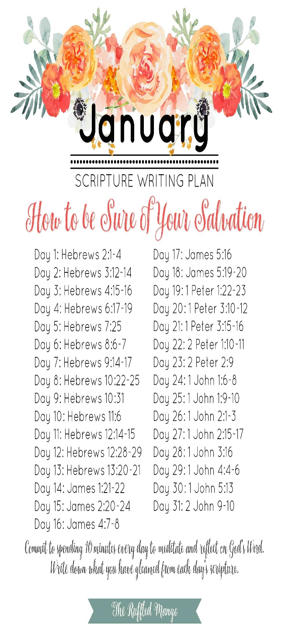

Every Tuesday in January
6:30 pm Bible Study

January 1, 2023
10:45 am Epiphany of the Lord

January 8
10:45 am Baptism of the Lord
Convent Renewal
Remember Your Baptism

February 19
10:45 am Transfiguation Sunday

February 22
7:00 pm Ash Wednesday Service

February 22 – April 6
Lent

SAVE THE DATE!
February 24, 2023
at Claremore FUMC

Ash Wednesday
February 8, 2023
The ashes come from palms that were burned from the previous Palm Sunday—the Sunday before Easter. Palm Sunday marks Jesus' triumphal entry into Jerusalem, where people waved palm branches to celebrate his arrival. The ashes are typically mixed with holy water or oil.

The Missions team will be collecting new and gently used blankets in the month of January.
The donated blankets will be distributed to the LG Food Pantry and the Tahlequah Day Center.
Please place your donated blankets in the bin next to the Church office.
Why do black-eyed peas
mean good luck?
The Confederates, however, survived by eating this crop and considered themselves lucky to have had them and, so, the peas became symbolic of luck.
First United Methodist Church of Locust Grove
P. O. Box 218
Locust Grove, OK 74352

